**Week 3 Module 3.2 Assignment**

Juan Macias Vasquez

Bellevue University

CSD310-H323 Database Development and Use (2255-DD)

**Adam Bailey**

June 15th, 2025

Module 3.2 Assignment

**Assignment:** **Normalized Tables**

**Authors, Publishers, Books table**

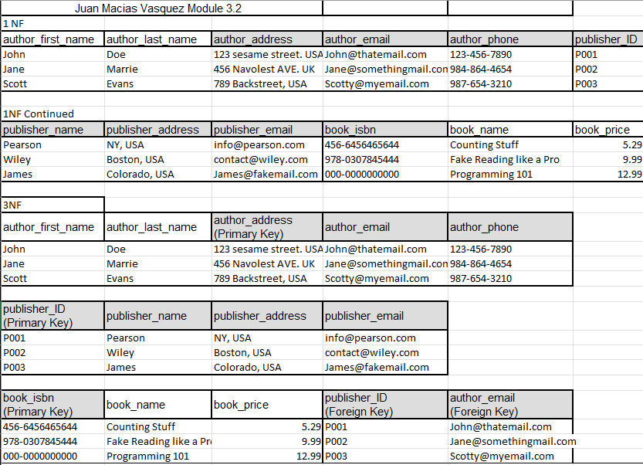

Made in Excel